Ghazian Thesis Proposal

York University, Toronto, ON

Nov. 19th, 2018

**A contrast of micro and macroclimatic effects on vertebrate interactions with foundational plant species.**

**Examination Committee:**

Dr. Christopher J. Lortie

Dr. Suzanne MacDonald

**Table 1. Summary** of each thesis chapter including, methods, progress, and timeline goal.

|  |  |  |  |  |
| --- | --- | --- | --- | --- |
| Chapter | Title | Methods | Progress | Timeline |
| 1 | **A systematic review of camera trap papers to test for reported sampling effort.** | Extract data for number of pictures taken, number of species seen, and location from peer-reviewed primary literature. | -Have 104 papers compiled | -Analyse data in January 2019 and have the manuscript by end of April 2019 |
| 2 | **Plant-animal interactions at an on-site level.** | Camera trap incidents of an animal near shrub for both 2017 and 2018 data in the Carrizo National Monument at 2 different sites shrub and open  -Obtain long term weather data of each region (at least for those two years)  -confirm behaviour with shrub using camera trap video data | -Imagery data all processed  -Long-term weather data for **precipitation, air temperature, soil temperature, relative humidity, and solar radiation** already obtained  -15,000 videos are processed | -Match data to weather February-April 2018  -Do stats May 2019  - Have a manuscript ready by Sep. 2019 |
| 3 | **Shelter effects on vertebrate animal interactions with foundation plant species.** | -Have 2 sites in Carrizo for the experiment  - microsite: open, shrub, shelter open, control, shelter temperature and soil, shelter radiation and deploy shelters  -Measure growth of plants, take soils samples before and after  -camera trap set at a few | -Field season 2019 Spring-Summer | -Have a manuscript ready by January 2020  -Wrap-up thesis by September 2020 |

**Background**

For decades, individualistic and competition theories were the topics most favoured by plant ecologists. However, Bertness and Callaway’s (1994) ‘stress-gradient-hypothesis’ (SGH) of competition to facilitation switch under stressful environmental conditions sparked the interest of many for the topic. Many studies have thus focused on facilitation in harsh environments including arid ecosystems (Maestre et al. 2009; Michalet et al. 2014; Lu et al. 2018). Facilitation is defined as an interaction where one interacting species benefits whilst none are harmed (Bertness and Leonard 1997). Although most facilitation research have focused on plant-plant interactions (Lortie, Filazzola, and Sotomayor 2016), the emergence of studies focusing on animal-shrub/plant has become more prevalent in recent years (Dalsgaard et al. 2011; Watson 2016).

At the centre of facilitation research lies the concept of foundational plant species or nurse plants, which are usually shrubs, perennials, trees or cushion plants that benefit other plant or taxa (Gómez-Aparicio et al. 2004) through various mechanistic pathways such as seed trapping, abiotic stress amelioration, soil modification, and pollinator visitation for other plants (Filazzola and Lortie 2014) and seed trapping, herbivore protection, magnet pollination and facilitation‐mediated secondary seed dispersal for animals. In particular, shrub canopy is thought to be the most important agent of structural facilitation for animals through direct and indirect shelter and refuge effects (Bråthen and Lortie 2016; Lortie et al. 2018). Hence, foundational plants serve as a great focal point for a variety of studies hoping to examine plant-plant, plant-animal, plant-plant-animal, or plant-animal-animal facilitation in a given ecosystem.

Desertification and arid region expansion are critical global change issues (Asner and Heidebrecht 2005). Temperature, variability in precipitation, extended drought periods, and radiation are probable factors affecting the function of foundation species (Kogan and Guo 2015; MacDonald 2007; Tattini et al. 2006). The changes in the above weather parameters are primarily due to anthropogenic climate change (Gibelin and Déqué 2003) that significantly modifies physical and biological systems in all continents (Rosenzweig et al. 2008). Few studies have focused on the effects of anthropogenic factors on animal behaviour or the conservation of general biodiversity (Berger-Tal et al. 2016). Thus, closing this research gap by examining behavioural-ecological domains such as movement and spatial pattern, forging and vigilance, social organization, and reproductive behaviour (Berger-Tal et al. 2011) against the landscape can provide crucial knowledge for conservation paradigms and frameworks. Weather can be defined as short-term (minutes to months) changes in atmospheric conditions, while climate is the long-term weather pattern of a particular region (NASA 2005). Here we refer to weather as micro-climate. Micro-climatic-driven behavioural plasticity can promote shifts in habitat so behavioural regimes can continue to function despite changes in climate (Noonan et al. 2018). Here, I propose that changes in weather parameters can alter vertebrate behaviour and hence their interactions with foundation plant species in deserts. Particularly, I’m interested in examining to what frequency and extend temperature and solar radiation can influence this interaction.

Carrizo Plain National Monument (35.1914° N, 119.7929° W) is the largest remnant ecosystem of the San Joaquin Desert located in the south-eastern San Louis Obispo Country (Noble et al. 2016). The dominant shrub species are *Ephedra californica* (Mormon tea) and *Atriplex polycarpa* (saltbush) (Stout et al. 2014). The species *E. californica* is a slow-growing shrub which spreads colonially in hot deserts (Sawyer, Keeler-Wolf, and Evens 2009). It is well-adapted to alluvial substrate and shifting sand, generally growing in elevations of 200-1200 m. Although severe fires can kill the plant (Anderson 2004), it is fairly resistant to moderate fires with the ability to sprout. Ephedra’s high abundance and resilience in this ecosystem makes it the perfect plant to study positive plant-animal interactions.

Open-top Chambers (OTC) are relatively inexpensive and provide a means to manipulate parameters such as CO2, temperature, soil temperature, solar radiation, and humidity (Chiba and Terao 2014; Welshofer et al. 2018). However, a cheaper alternative is UV-permeable Perspex shelters that can be used to increase the temperature, allow airflow, and change radiation intensity and UV permeability. To the best of our knowledge, no experiment has paired Perspex shelter designs with camera traps in order to examine the impact of manipulations of the above parameters on animal behaviour. The closed analog is animal monitoring under solar panel arrays (Wilhelm, Blackshire, and Lanzone 2017), but these surveys typically include full light exclosures by the panels. Camera trapping allows researcher to obtain wildlife data with relatively little to no human disturbance (O’Connell et al. 2011; Trolliet et al. 2014). Previous studies have explored the use of cam traps to estimate population size (Karanth 1995), examine wildlife behaviour (Dupuis-Desormeaux et al. 2015), and explore activity patterns and habitat use (Bowkett, Rovero, and Marshall 2008). Although cam traps have been used to look at animal interactions with plants to an extent (Paviolo et al. 2018), using them explore shelter effects and interactions with foundation plants is both novel and critical to better understand solar farm deployments in desert ecosystems and their use for conservation purposes.

Chris’ comment:

ALSO – I think you should reorganize and can just talk about shelter effets in general and list all the ways that animals can be impacted and also reponds. THEN state that temperature could be a very important negative?? Or positive factor? On some animals and positive/negative to others – ie depends if lizards or small mammals right? Also, we want to know really very directly if ‘thermal refuges’ provided by foundation species are CRITICAL – this is the MAIN idea and needs to pop…. Develop a bit and explain please. Things likely getting hotter and drier too – shrubs and other foundation species are refuge for animals and other plants from these effects etc and here we want to warm microsites and also test general general shelter effects…. SO – are we sure our shelters will not cool??? Ie they will provide shade??? OR really are you testing shade effects on animals near shrubs and in the open??? IF SO – STILL COOL but you will need to also test warming – IF that is what you want via OTCs too – OR just do shelter and measure temperatures with hobo pendant loggers and use the natural variation under shrubs, in the open, and then under shrubs with a shelter over top and in the open with a shelter over top – ALSO great – I think this latter option is totally fine and also really SIMPLE!!!

Despite previous literature’s focus on closing the gaps that exists in photographic rates as an index of density (Carbone et al. 2001; Rovero and Marshall 2009), to my knowledge no single study to this date has been published that concentrates on generating rarefaction curves of number images versus species richness compiled from previous research data. Rarefaction curves can gives us insight into the sampling effort required for this type of trapping in a given environment in order to accurately determine species richness- a novel gap that exists in the current literature.

**Chapter 1: A systematic review of camera traps to generate species rarefaction curves**

**Purpose:** Identify the relevant literature using camera traps to examine sampling efficacy for abundance and richness of animals with this trapping tool.

**Questions:** In which ecosystems was camera trapping done? What was the duration of sampling? How many pictures were taken? How many had animals in them? What were the animals (species)? How many species in reality settle in that habitat (GBIF)? What was the sampling area? Was the total area sampled reported? Was the camera field of view reported?

**Hypothesis:** There a few studies exploring photogenic rate as an index of density, though there is a lack of literature which has created rarefaction curves from previously published literature data-a research gap that needs more attention. These graphs can be used to estimate the abundance and richness in a given area, in addition to the number of cameras needed to be deployed for sufficient data.

**Predictions:** Many studies using camera traps focus on one type of species which makes it difficult to record species richness of a given area. Furthermore, I predict that most studies will solely report either the duration of camera trapping or the number of photos. Studies will also rarely focus on minimizing repeat visits. Thus it will be important to generate a method that is able to obtain the most amount of data from the published literature in order to generate the best estimates for sampling effort across.

**Methods:** Figure 1 represents the workflow for extracting relevant data. Literature will be obtained through keyword searches in Web of Science using a mixture of the keywords listed in the figure. Abstracts will be reviewed and all opinion, review, and idea papers will be removed so that the focus remains on actual field studies. Selected papers must contain the number of pictures taken, the number of animals spotted and which species, and the location. Preferably, latitude and longitude coordinates are also obtained from the studies, as well as sampling duration, and camera field of view.

**Preliminary Results:** Thus far, 104 papers are combined through keyword searches. Not all list the variables of interest, but most do list some combination. A closer look would determine whether enough studies provide us with key variables needed for this systematic review.

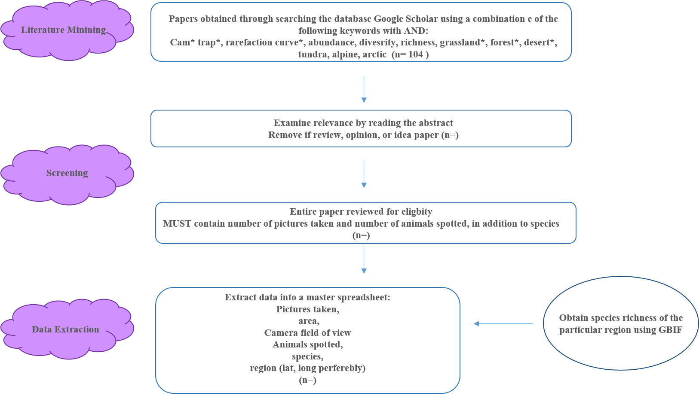

**Figure 1:** Workflow used to select the relevant literature for generating rarefaction curves from cam trap literature.

**Chapter 2: A look at the effects of various weather parameters on shrub-animal interactions at an on-site level.**

**Purpose:** To explore whether animal association patterns with shrubs are explained by site-level daily weather data.

**Questions:** How do temperature, precipitation, solar radiation, and humidity influence the associational patterns of vertebrates with shrubs? How does the strength of this association change as the above parameters increase or decrease?

**Hypotheses and predictions:** Because shrubs are thermal refuge for many desert animal populations, as temperature increases the association for some animal species also increases. Furthermore, seasonal variation, time of the day, and shrub size all modify shrub-animal interactions. This is because the extend to which different animals rely on shrubs as a form of refuge differs depending on the species’ physiology i.e pikotherms vs. endotherms.

**Methods:**

**Cam trapping**

Camera trapping has been done in the Spring-Summer of 2017 in the Carrizo National Monument at 2 different sites: the same sites were re-sampled in 2018 for a total of three weeks. Coordinates of each microsite can be found here: <https://github.com/nargolg1/Anima-Behaviour-and-Climate-project/blob/master/proposal/Camtraps%20pics.xlsx>

Cameras were moved around to maximize incidents of associational observation. Each camera was deployed facing a shrubs with their respective open microsite facing the back to serve as control. Cameras were exactly at ground level at any given coordinate and secured using pegs.

**Processing**

Images collected were saved as Join Photographic Expert Group (JPEG) format. These dataframes were then manually examined for the presence of animals. A datasheet was created where every row corresponded to a unique image. Additionally, data was recorded for the year, region, calendar date, microsite, rep, photo rep, and week number. If a vertebrate was present in the photo, further info on the type of vertebrate, time block, actual time, temperature, and additional observations were also recorded. Images from cameras were clear enough during both day and night (low light condition) to distinguish between animals. An animal was classified as present if as little as a section of a body part (i.e. tail) made it into the captured image. Because the dates and timestamps are generally wrong on these traps, dates must be manually corrected manually or in R. Behavioural data are to be obtained from video traps as a collaborative effort with Mario. For the most part the same parameters as above are to be recorded alongside behaviour.

**Site-level climate data**

Carrizo data for weather parameters of interest for both 2017 and 2018 were obtained from the following website and saved in a datasheet:

<http://ipm.ucanr.edu/calludt.cgi/WXSTATIONDATA?MAP=&STN=BLACKWLL.A>

Data was obtained for air temperature, soil temperature, solar radiation, and relative humidity.

**Statistics**

Point-biseral correlation analyses are to be performed examining the relationship between the continuous weather variable and the binary variable presence/absence of animal (Gupta 1960). Effects of covariates may be studied through an ANCOVA. Effects of multiple weather parameters may be explored through Principle Component Analysis (PCA) (Bryant and Yarnold 1995). All stats will be performed in R version 5.3.1 (R Development Core Team 2018). Data repository can be found here: <https://github.com/nargolg1/Anima-Behaviour-and-Climate-project>

**Chapter 3: shelter experiment to manipulate micro-climatic conditions.**

**Purpose:** To physically manipulate temperature and solar radiation intensity using UV permeable Perspex shelters paired with camera traps to examine how the increase/decrease in in the above parameters affects animal-plant shrub associational parents.

**Hypotheses and predictions:** Foundation species, shelter, and relatively large objects in desert ecosystems influence association behaviour and population dynamics including movement. This is likely due to the benefits provided through various mechanistic pathways to the beneficiaries. Additionally, the presence of a foundational species will likely increase the soil microbiota due to the benefits provided by the plant (Bodelier et al. 2006).

**Methods:** shelters will be built in the field from UV permeable Perspex glued together (Figure 2). Each shelter will be high enough to account for the height of the individual shrub; however, chosen shrubs will generally be of the same volume and stature to minimize treatment differences. A hole will allow for the entrance and exit of animals. The presence of the shelter will result in an increase in temperature which will be measured by temperature loggers. Soil temperature and relative humidity will also be recorded via loggers. Solar radiation intensity can be manipulated by Plexiglas of different darkness intensity that are either UV permeable or impermeable. Soil microbiota samples will be taken once before the start of the study and once when the study is completed in order to be analyzed so possible microbial differences before and after can be studies. Shelter sites would be paired with simple open and shrub microsites. Furthermore, a mesh shelter that does not manipulate any weather parameters will be used as control. Shrub height, length, and width (x, y, and z) dimensions will also be recorded once before and after the study is finished for both shelter and non-shelter microsites. The study will take place in site 3 and 4 of Carrizo. Table 2 summarizes the treatments and replications. Cam traps will be paired with 4 sets of shrubs, 4 sets of open, and 4 sets of shelters (2 sets in each site).

**Stats**

Statistical analyses will focus on examining the variance within and between groups for the parameters to be tested.

**Table 2.**  **Replication** breakdown for open-shrub microsites and shelters.

|  |  |  |  |
| --- | --- | --- | --- |
| **Microsite** | **Shelter** | **Replication** | **Total** |
| **2** | **4** | **X 8:**  **X4 in site 3**  **X4 in site 4** | **64** |
| Shrub | Light completely blocked |
| Open | Temperature |
|  | Radiation intensity |
| Mesh shelter (control) |  | |

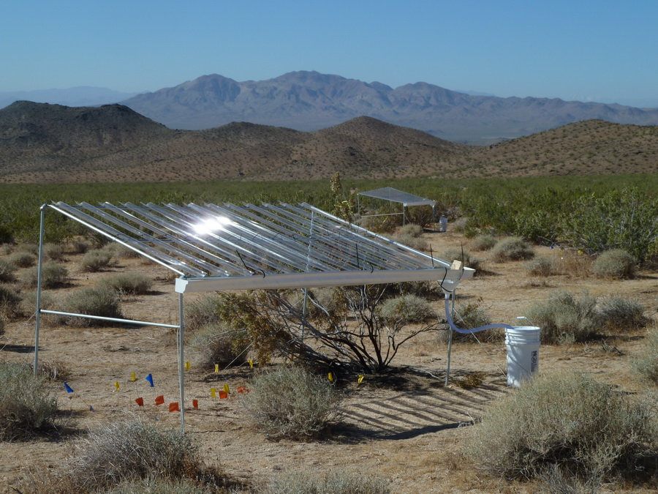

**Figure 2:** Perspex shelters to be built will be similar to the above design; though, two of the sides will also most likely be covered with Perspex and metal bars will not be used. For shelters where the light is to be completely blocked off, all sides will be covered with dark Perspex.

**References**

Asner, Gregory P., and Kathleen B. Heidebrecht. 2005. “Desertification Alters Regional Ecosystem-Climate Interactions.” *Global Change Biology* 11 (1): 182–94. https://doi.org/10.1111/j.1529-8817.2003.00880.x.

Berger-Tal, O., T. Polak, A. Oron, Y. Lubin, B. P. Kotler, and D. Saltz. 2011. “Integrating Animal Behavior and Conservation Biology: A Conceptual Framework.” *Behavioral Ecology* 22 (2): 236–39. https://doi.org/10.1093/beheco/arq224.

Berger-Tal, Oded, Daniel T. Blumstein, Scott Carroll, Robert N. Fisher, Sarah L. Mesnick, Megan A. Owen, David Saltz, Colleen Cassady St. Claire, and Ronald R. Swaisgood. 2016. “A Systematic Survey of the Integration of Animal Behavior into Conservation: Animal Behavior and Conservation.” *Conservation Biology* 30 (4): 744–53. https://doi.org/10.1111/cobi.12654.

Bertness, Mark D., and Ragan Callaway. 1994. “Positive Interactions in Communities.” *Trends in Ecology & Evolution* 9 (5): 191–93. https://doi.org/10.1016/0169-5347(94)90088-4.

Bertness, Mark D., and George H. Leonard. 1997. “THE ROLE OF POSITIVE INTERACTIONS IN COMMUNITIES: LESSONS FROM INTERTIDAL HABITATS.” *Ecology* 78 (7): 1976–89. https://doi.org/10.1890/0012-9658(1997)078[1976:TROPII]2.0.CO;2.

Bodelier, Paul L. E., Maayke Stomp, Luis Santamaria, Marcel Klaassen, and Hendrikus J. Laanbroek. 2006. “Animal–Plant–Microbe Interactions: Direct and Indirect Effects of Swan Foraging Behaviour Modulate Methane Cycling in Temperate Shallow Wetlands.” *Oecologia* 149 (2): 233–44. https://doi.org/10.1007/s00442-006-0445-9.

Bowkett, Andrew E., Francesco Rovero, and Andrew R. Marshall. 2008. “The Use of Camera-Trap Data to Model Habitat Use by Antelope Species in the Udzungwa Mountain Forests, Tanzania.” *African Journal of Ecology* 46 (4): 479–87. https://doi.org/10.1111/j.1365-2028.2007.00881.x.

Bråthen, Kari Anne, and Christopher Lortie. 2016. “A Portfolio Effect of Shrub Canopy Height on Species Richness in Both Stressful and Competitive Environments.” Edited by Richard Michalet. *Functional Ecology* 30 (1): 60–69. https://doi.org/10.1111/1365-2435.12458.

Bryant, Fred B., and Paul R. Yarnold. 1995. “Principal-Components Analysis and Exploratory and Confirmatory Factor Analysis.” In *Reading and Understanding Multivariate Statistics.*, 99–136. Washington, DC, US: American Psychological Association.

Carbone, C., S. Christie, K. Conforti, T. Coulson, N. Franklin, J. R. Ginsberg, M. Griffiths, et al. 2001. “The Use of Photographic Rates to Estimate Densities of Tigers and Other Cryptic Mammals.” *Animal Conservation* 4 (1): 75–79. https://doi.org/10.1017/S1367943001001081.

Chiba, Masahiro, and Tomio Terao. 2014. “Open-Top Chambers with Solar-Heated Air Introduction Tunnels for the High-Temperature Treatment of Paddy Fields.” *Plant Production Science* 17 (2): 152–65. https://doi.org/10.1626/pps.17.152.

Deborah Stout, Jennifer Buck-Diaz, Sara Taylor, and Julie M. Evens. 2014. “Vegetation Mapping and Accuracy Assessment Report for Carrizo Plain National Monument. California Native Plants Society.” https://www.cnps.org/cnps/vegetation/pdf/carrizomapping_rpt2013.pdf.

Dupuis-Desormeaux, Marc, Zeke Davidson, Mary Mwololo, Edwin Kisio, Sam Taylor, and Suzanne E. MacDonald. 2015. “Testing the Prey-Trap Hypothesis at Two Wildlife Conservancies in Kenya.” Edited by Stephanie S. Romanach. *PLOS ONE* 10 (10): e0139537. https://doi.org/10.1371/journal.pone.0139537.

Filazzola, Alessandro, and Christopher J. Lortie. 2014. “A Systematic Review and Conceptual Framework for the Mechanistic Pathways of Nurse Plants: A Systematic Review of Nurse-Plant Mechanisms.” *Global Ecology and Biogeography* 23 (12): 1335–45. https://doi.org/10.1111/geb.12202.

Gibelin, A.-L., and M. Déqué. 2003. “Anthropogenic Climate Change over the Mediterranean Region Simulated by a Global Variable Resolution Model.” *Climate Dynamics* 20 (4): 327–39. https://doi.org/10.1007/s00382-002-0277-1.

Gómez-Aparicio, Lorena, Regino Zamora, Jose M. Gómez, Jose A. Hódar, Jorge Castro, and Elena Baraza. 2004. “APPLYING PLANT FACILITATION TO FOREST RESTORATION: A META-ANALYSIS OF THE USE OF SHRUBS AS NURSE PLANTS.” *Ecological Applications* 14 (4): 1128–38. https://doi.org/10.1890/03-5084.

Gupta, S. Das. 1960. “Point Biserial Correlation Coefficient and Its Generalization.” *Psychometrika* 25 (4): 393–408. https://doi.org/10.1007/BF02289756.

Karanth, K. Ullas. 1995. “Estimating Tiger Panthera Tigris Populations from Camera-Trap Data Using Capture—Recapture Models.” *Biological Conservation* 71 (3): 333–38. https://doi.org/10.1016/0006-3207(94)00057-W.

Kogan, Felix, and Wei Guo. 2015. “2006–2015 Mega-Drought in the Western USA and Its Monitoring from Space Data.” *Geomatics, Natural Hazards and Risk* 6 (8): 651–68. https://doi.org/10.1080/19475705.2015.1079265.

Lortie, Christopher J., Alessandro Filazzola, and Diego A. Sotomayor. 2016. “Functional Assessment of Animal Interactions with Shrub-Facilitation Complexes: A Formal Synthesis and Conceptual Framework.” Edited by Richard Michalet. *Functional Ecology* 30 (1): 41–51. https://doi.org/10.1111/1365-2435.12530.

Lortie, Christopher J., Eva Gruber, Alex Filazzola, Taylor Noble, and Michael Westphal. 2018. “The Groot Effect: Plant Facilitation and Desert Shrub Regrowth Following Extensive Damage.” *Ecology and Evolution* 8 (1): 706–15. https://doi.org/10.1002/ece3.3671.

Lu, Rong, Jiyong Zheng, Chao Jia, Yu Liu, Ze Huang, Honghua He, Fengpeng Han, and Gao-Lin Wu. 2018. “Nurse Effects of Patch-Canopy Microhabitats Promote Herbs Community Establishment in Sandy Land.” *Ecological Engineering* 118 (August): 126–33. https://doi.org/10.1016/j.ecoleng.2018.04.019.

MacDonald, Glen M. 2007. “Severe and Sustained Drought in Southern California and the West: Present Conditions and Insights from the Past on Causes and Impacts.” *Quaternary International* 173–174 (October): 87–100. https://doi.org/10.1016/j.quaint.2007.03.012.

Maestre, Fernando T., Ragan M. Callaway, Fernando Valladares, and Christopher J. Lortie. 2009. “Refining the Stress-Gradient Hypothesis for Competition and Facilitation in Plant Communities.” *Journal of Ecology* 97 (2): 199–205. https://doi.org/10.1111/j.1365-2745.2008.01476.x.

Michalet, Richard, Yoann Le Bagousse-Pinguet, Jean-Paul Maalouf, and Christopher J. Lortie. 2014. “Two Alternatives to the Stress-Gradient Hypothesis at the Edge of Life: The Collapse of Facilitation and the Switch from Facilitation to Competition.” Edited by Michael Palmer. *Journal of Vegetation Science* 25 (2): 609–13. https://doi.org/10.1111/jvs.12123.

Michelle D. Anderson. 2004. “Ephedra Nevadensis. In: Fire Effects Information System.” U.S. Department of Agriculture, Forest Service, Rocky Mountain Research Station, Fire Sciences Laboratory. https://www.fs.fed.us/database/feis/plants/shrub/ephnev/all.html.

Noble, Taylor J., Christopher J. Lortie, Michael Westphal, and H. Scott Butterfield. 2016. “A Picture Is Worth a Thousand Data Points: An Imagery Dataset of Paired Shrub-Open Microsites within the Carrizo Plain National Monument.” *GigaScience* 5 (1). https://doi.org/10.1186/s13742-016-0145-2.

Noonan, Michael J., Chris Newman, Andrew Markham, Kirstin Bilham, Christina D. Buesching, and David W. Macdonald. 2018. “In Situ Behavioral Plasticity as Compensation for Weather Variability: Implications for Future Climate Change.” *Climatic Change* 149 (3–4): 457–71. https://doi.org/10.1007/s10584-018-2248-5.

O’Connell, Allan F., James D. Nichols, and K. Ullas Karanth, eds. 2011. *Camera Traps in Animal Ecology*. Tokyo: Springer Japan. https://doi.org/10.1007/978-4-431-99495-4.

Paviolo, Agustin, Paula Cruz, María Eugenia Iezzi, Julia Martínez Pardo, Diego Varela, Carlos De Angelo, Silvia Benito, et al. 2018. “Barriers, Corridors or Suitable Habitat? Effect of Monoculture Tree Plantations on the Habitat Use and Prey Availability for Jaguars and Pumas in the Atlantic Forest.” *Forest Ecology and Management* 430 (December): 576–86. https://doi.org/10.1016/j.foreco.2018.08.029.

R-Core Team 2017 stats. *R package*, R version 3.4.4.

Rosenzweig, Cynthia, David Karoly, Marta Vicarelli, Peter Neofotis, Qigang Wu, Gino Casassa, Annette Menzel, et al. 2008. “Attributing Physical and Biological Impacts to Anthropogenic Climate Change.” *Nature* 453 (May): 353.

Rovero, Francesco, and Andrew R. Marshall. 2009. “Camera Trapping Photographic Rate as an Index of Density in Forest Ungulates.” *Journal of Applied Ecology* 46 (5): 1011–17. https://doi.org/10.1111/j.1365-2664.2009.01705.x.

Tattini, Massimiliano, Damiano Remorini, Patrizia Pinelli, Giovanni Agati, Erica Saracini, Maria Laura Traversi, and Rossano Massai. 2006. “Morpho-Anatomical, Physiological and Biochemical Adjustments in Response to Root Zone Salinity Stress and High Solar Radiation in Two Mediterranean Evergreen Shrubs, Myrtus Communis and Pistacia Lentiscus.” *New Phytologist* 170 (4): 779–94. https://doi.org/10.1111/j.1469-8137.2006.01723.x.

Trolliet, Franck, Marie-Claude Huynen, Cédric Vermeulen, and Alain Hambuckers. 2014. “Use of Camera Traps for Wildlife Studies. A Review.” *Biotechnol. Agron. Soc. Environ.*, 9.

Welshofer, Kileigh B., Phoebe L. Zarnetske, Nina K. Lany, and Luke A.E. Thompson. 2018. “Open-Top Chambers for Temperature Manipulation in Taller-Stature Plant Communities.” Edited by Sarah Goslee. *Methods in Ecology and Evolution* 9 (2): 254–59. https://doi.org/10.1111/2041-210X.12863.

Wilhelm, Jay, Sheldon Blackshire, and Michael Lanzone. 2017. “Energy-Neutral Data Collection Rate Control for IoT Animal Behavior Monitors.” *Applied Sciences* 7 (11): 1169. https://doi.org/10.3390/app7111169.